**Swiggy Funnel Analysis Capstone – Project Report**

Submitted to: Skillovilla

Date: 19th Nov 2024

Submitted by: Bijay Kumar Maity

**Contents**

**Introduction** 3

**Purpose of Analysis** 3

**Insights from the Dashboard** 3

**Analysis and Findings** 4

**Recommendation** 5

**Conclusion** 6

# **Introduction**

Swiggy, one of India’s largest food eCommerce platforms, serves over one million users daily. In 2019, its growth trajectory was influenced by various factors, including user sessions, traffic sources, and customer engagement metrics. This report provides a detailed funnel analysis to uncover key insights regarding Swiggy's performance, focusing on identifying trends in user sessions, traffic changes, and conversion fluctuations.

By analyzing the ‘Funnel Case Study Data,’ which contains session details, traffic sources, and supporting data, this report aims to provide actionable insights to enhance Swiggy’s growth strategies.

# **Purpose of Analysis**

The purpose of this analysis is to:

1. Identify trends and anomalies in the number of orders and sessions on Swiggy in 2019.
2. Pinpoint the dates with significant order fluctuations (both highs and lows) compared to the same day of the previous week.
3. Examine traffic and conversion rate variations to determine their root causes.
4. Evaluate key funnel metrics (L2M, M2C, C2P, P2O) to identify areas of improvement.
5. Formulate hypotheses to explain performance changes and validate them using supporting data.
6. Provide actionable insights to improve Swiggy’s operational efficiency and user experience.

# **Insights from the Dashboard**

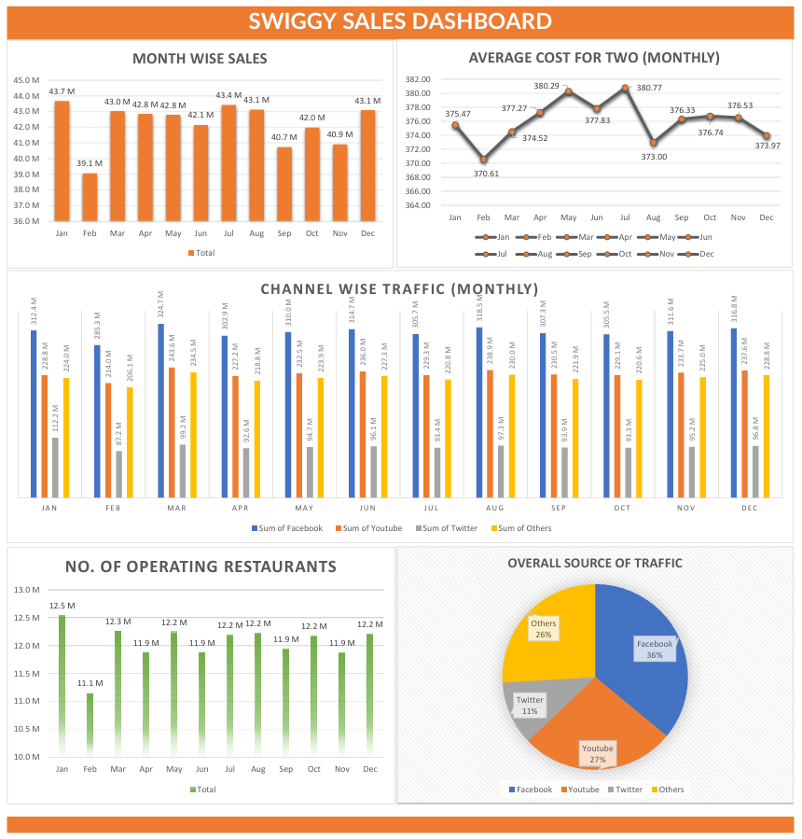

* **February Sales Dip:** Sales dropped significantly in February, likely due to seasonality or fewer operational days, but recovered in March.
* **Key Traffic Drivers:** Facebook (36%) and YouTube (27%) are the primary traffic sources, requiring focused marketing efforts.
* **Unexplored Traffic Potential:** The "Others" category (26% traffic) presents an opportunity for deeper analysis and optimization.
* **July Pricing Success:** The highest average cost for two in July indicates a pricing strategy worth replicating.
* **Stable Operations:** Operating restaurants grew early in the year and stabilized, offering a strong base for consistent service and potential expansion.

# **Analysis and Findings**

Date-wise analysis for fluctuations over (+/-20%) with respect to the same day in the previous week:  
  
***Note****: Highlighted cells are for the lowest and highest conversion rates*

|  |  |  |
| --- | --- | --- |
| **Date** | **Order change w.r.t same day last week** | **Reason** |
| 10-01-2019 | -45% | Reduction in orders due to reduction in Traffic by -49% (FB -95%, YT and TW -49%) |
| 17-01-2019 | 106% | Increase in orders due to increase in Traffic by +110% (FB +1980%, YT and TW +110%) |
| 21-01-2019 | 23% | Increase in orders (1.48M) due to M2C increase at (42%), Images per restaurant Increased from (31) to (37) |
| 22-01-2019 | 85% | Highest orders (2.22M) due to Increase in Traffic by +77% (FB +77%, YT -66%, TW +747%, Others -66%) |
| **29-01-2019** | **-72%** | **Reduction of Traffic by -40% (FB -40%, Others -80%) Count of Restaurants lowest at 0.27M resulting in a decline in order conversion at (3%)** |
| 05-02-2019 | 115% | Increase in conversion +115%, Traffic constant but count of restaurants at (0.4M) |
| 19-02-2019 | -56% | Reduction in conversion rate by -54% due to decrease in M2C from conversion (39%) to (17%) |
| 26-02-2019 | 120% | Increase in conversion rate by +110% due to increase in M2C conversion from (17%) to (41%) |
| 28-02-2019 | 22% | Increase in conversion rate by +13% due to increase in traffic by 8%, Average out-of-stock items reduced from (36) to (30) |
| 02-03-2019 | -38% | Lowest Overall conversion at (2%), Highest Average Delivery Charges at (56) resulting in Lowest C2P at (33%) |
| 09-03-2019 | 102% | Increase in conversion rate by +102% due to Reduction in Average Delivery Charges to Half at (28) |
| 19-03-2019 | -46% | Reduction in orders (0.7M) Lowest P2O at (39%) and Lowest Success Rate of payments at (65%) which could mean an issue with the Payment options on the app |
| 24-03-2019 | 22% | Increase in conversion rate due to slight increase in traffic (+6%) due to it being a Weekend |
| 26-03-2019 | 78% | Increase in conversion rate by +87% as the Success Rate of payments is at (94%) as compared to the lowest of (65%) from previous week |
| 04-04-2019 | -52% | Reduction in orders (0.6M) and conversion rate -53% due to Lowest Average discount at (10%) |
| 11-04-2019 | 92% | Increase in conversion rate due to increase in discount % at (18%) and slight reduction in Avg. packaging (19) and delivery charges (25) |
| 12-04-2019 | -27% | Reduction in conversion rate by -20% due to slight change in Traffic (-9%) |
| 14-04-2019 | 28% | Increase in conversion rate by 19% due to change in Traffic (8%) due to it being a Weekend |
| 18-04-2019 | 73% | Increase in conversion rate due to Highest Overall conversion (9%) and Highest average discount (29%) |
| 19-04-2019 | 25% | Increase in conversion rate by +16%, Highest C2P at (77%) |
| 25-04-2019 | -39% | Reduction in conversion rate by -39% due to reduction in average discount from (29%) to (17%) |
| 20-06-2019 | -54% | Reduction in orders (0.6M) and conversion rate due to reduction in Traffic by -53% for all channels |
| 27-06-2019 | 115% | Increase in orders (1.3M) due to increase in Traffic by +119% for all Channels, correction from the previous weeks low of -54% |
| 16-07-2019 | -63% | Lowest Overall Conversion (2%) and Lowest L2M (10%) due to Highest Average Cost for two (458) |
| **23-07-2019** | **135%** | **Increase in conversion rate from the previous week by 128% due to L2M increase to 24% resulting from reduced average cost for two, packaging and delivery charges** |
| 11-08-2019 | -54% | Lowest Overall conversion at (2%), Highest Average Packaging Charges at (29) resulting in Lowest C2P at (33%) |
| 18-08-2019 | 107% | Increase in conversion rate by +100% due to Average packaging charges reduced to (20) resulting in C2P increase to (65%) |
| 14-09-2019 | -54% | Lowest Overall conversion at (2%) with M2C reduced to (15%) due to an increase in average out-of-stock items to (64) |
| 21-09-2019 | 112% | Increase in conversion to +114% with M2C increased to (34%) and out-of-stock items reduced to (37) from (64) in the previous week |
| 09-10-2019 | 22% | Increase in overall conversion to +27% from -19% in the previous week, Highest C2P at (77%) |
| 21-10-2019 | 32% | Increase in overall conversion to +21% from -17% in the previous week |
| 09-11-2019 | 26% | Increase in conversion rate by 18% due to change in Traffic (7%) due to it being a Weekend thereby increasing the M2C and P2O conversions |
| 17-11-2019 | -57% | Lowest Overall conversion at (2%) with M2C reduced to (14%) due to Highest Average out of stock items to (112) |
| **24-11-2019** | **135%** | **Increase in conversion rate from the previous week by 124% due to L2M increase to 34% resulting in reduced average out-of-stock items to (34)** |
| 01-12-2019 | 21% | Increase in conversion rate from the previous week by 20% |
| 22-12-2019 | 21% | Increase in conversion rate from the previous week by 21% |

# **Recommendation**

Below are recommendations aimed at strengthening Swiggy’s relationships with stakeholders and improving overall sales and profitability:

* **Strengthen Relationships with Partner Restaurants**
* Develop long-term collaborations with partner restaurants through regular communication.
* Offer incentives such as reduced commission rates, marketing support, or exclusive promotions to encourage restaurant loyalty and consistent availability.
* **Performance Recognition Programs for Delivery Partners**
* Implement incentive programs such as bonuses, rewards, or recognition for high-performing delivery partners.
* A motivated and well-compensated delivery team can enhance customer satisfaction and operational efficiency.
* **Run Targeted Promotions**
* Focus on channels like Twitter, which drive the lowest traffic, by running channel-specific promotions.
* Highlight exclusive offers available only on underperforming platforms to increase user engagement and conversions.
* **Segmented Pricing Tiers**
* Introduce segmented pricing based on customer spending behavior.
* Capitalize on insights from the highest conversion rate of 9% when discounts were offered by tailoring offers to different market segments.
* **Offer Incentives for Pre-Orders**
* Provide exclusive discounts or promotions for users opting for pre-orders, encouraging advanced planning.
* Pre-orders can help restaurants plan inventory and reduce instances of out-of-stock items.
* **Customer Feedback Analysis**
* Collect and analyze customer feedback to identify pain points and areas for improvement in the user journey.
* Use insights to optimize the customer experience and increase conversion rates.
* **Continuous Monitoring and Adjustment**
* Regularly monitor conversion rates, user feedback, and market trends.
* Adapt strategies in real-time to ensure alignment with user preferences and market conditions.

# **Conclusion**

The analysis highlights Swiggy's stable growth and areas for improvement, such as underperforming traffic channels and conversion fluctuations. Recommendations like strengthening restaurant partnerships, incentivising delivery partners, targeting low-traffic channels, and implementing segmented pricing can boost engagement and profitability. By offering pre-order incentives, analysing customer feedback, and monitoring metrics, Swiggy can enhance user experience and foster long-term loyalty. This data-driven approach will help Swiggy optimize operations and sustain growth in the competitive food eCommerce market.